HealthApp Automation- Maternity Module

Pre-requisite:

As soon as you import project in eclipse, update the project using maven update option as below. This is to resolve issue if any maven dependency not downloaded properly:

1. Right click on project : Go to “Maven” : Select “Update Project”

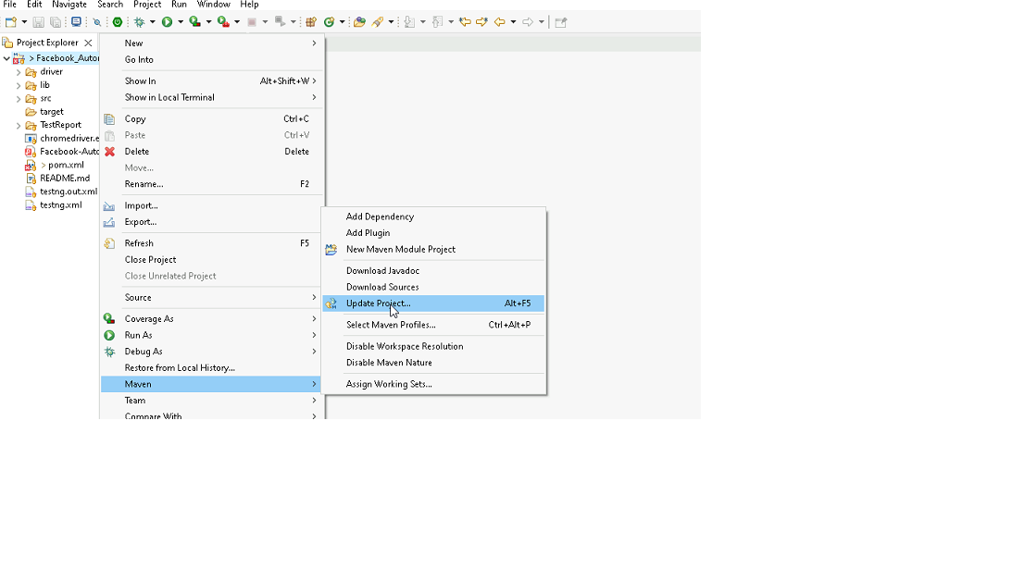

1. In Update Maven Project Box Select “Force Update of Snapshots/Releases” and click OK

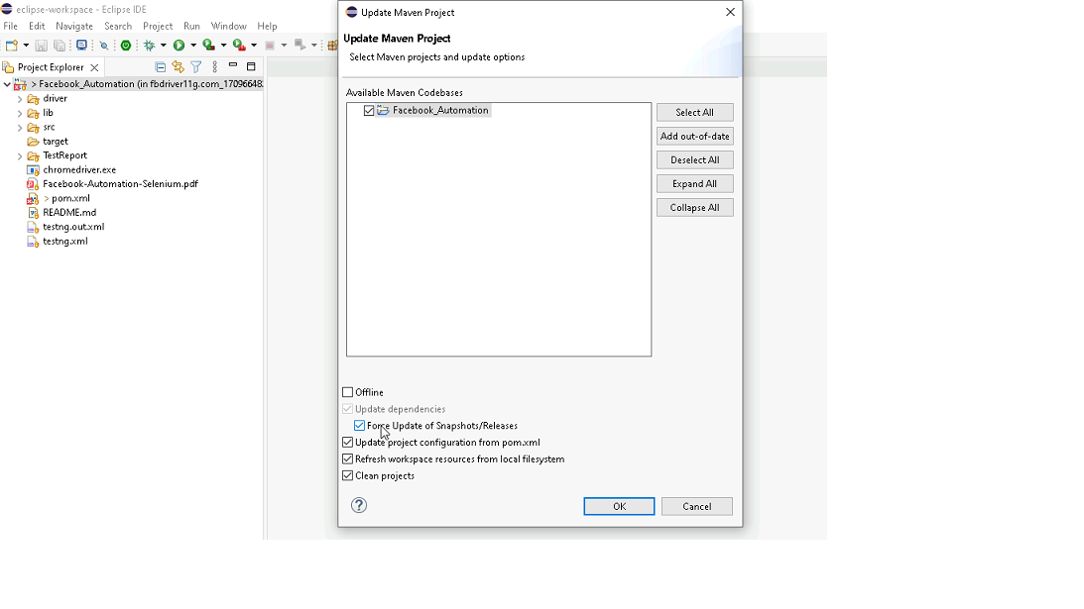

Template Code Structure:

1. Below are the packages and files you will be required to work upon.
2. Other Files and packages you can ignore.
3. In other Files and packages do not do any changes. It would affect your evaluation.
4. You are not required to work in “Test” Folder. Files there are non-editable. Editing those files and trying to save them will throw error and would affect your evaluation.

|  |  |  |
| --- | --- | --- |
| **Package** | **Class/File** | **Description** |
| src/main/java/coreUtilities/utils/ | FileOperations.java | 1. Contains methods to read from excel file. 2. Method is in templated form. 3. **You will be required to implement these methods as very first activity, because even URL to navigate to, is read using these methods.** |
| /src/main/java/pages | maternity_page.java | 1. All core activities (mentioned in list above) to be performed here. 2. The comments associated with each templated method here describe the expectation. 3. You can define locators and xpath here. 4. Declare any variable/object you need to share data/status between different methods. 5. Do not modify the signature of methods declared here. 6. You can create additional supportive common methods in CommonEvents class. |
| /src/main/resources/ | Config.xlsx | URL to navigate to. Already URL is defined here |
|  | expected_data.xlsx | Contains data to fill in form |
| /src/main/java/coreUtilities/utils | CommonEvents.java | 1. Contains all common activities. 2. Certain templated common method declared here. 3. You implement them as per your need. 4. You can add any additional method for common activity here |
|  | Testng.xml | Execution needs to kick started from TestNG xml |

PROBLEM STATEMENT

Need to automate the following activities using Selenium + Java.

Key Activities to implement:

|  |  |  |  |
| --- | --- | --- | --- |
| **Sl No.** | **Summary** | **Action** | **Expected Result** |
| **1** | Verify the Maternity module is present or not | 1. go to URL :[**https://healthapp.yaksha.com/**](https://healthapp.yaksha.com/)  2. login as valid credential **(username : admin , password : pass123)** and click on "**SignIn**" Button 3. Scroll down menu till Maternity  4. Click on the Maternity | Maternity module should be present |
| **2** | Verify all sub-modules are displayed correctly after Clicking on the "Maternity " Module. | Pre-condition: User should be logged in and it is on Maternity module 1. Click on the Maternity Module drop-down arrow | All sub-modules should be displayed correctly. Expected Sub modules are : Maternity List , Payments , Reports |
| **3** | Verify to navigate to each sub-module which are present in the "Maternity" module | Pre-condition: User should be logged in and it is on Maternity module  1. Navigate to the "Maternity List" sub-module 2. Click on the "Payments" sub-module  3. Click on the "Reports" sub-module  4. Navigate back to the "Maternity" sub-module | Ensure that it should navigate to each sub-module which are present in the "Maternity" module |
| **4** | Verify the presence of Maternity list with all fields | Pre-condition: User should be logged in and it is on Maternity module 1. Navigate to "Maternity list" sub-module | Maternity lit sub-module should be present  Expected value that are present in "Maternity list" sub-module are   1. Buttons: First, Previous, Next, Last, Ok, Print, View 2. Fields: search bar, Edit Information Of 3. Drop down: Date range, "..."(3 dots) 4. Check-box: View all Maternity Patient 5. Date Picker: From, To 6. Tooltip: Star figure |
| **5** | Create Maternity record in the "Maternity “list by enter existing patient name in "Edit Information of" field | Pre-condition: User should be logged in and it is on Maternity module 1. Navigate to "Maternity list" sub-module. 5. Enter the patient name as "Akshit" in the "Edit Information of" field  6. Select the patient name from the dropdown 7. Enter the necessary field in the "New Patient Registration" page (Husband's Name, Patient Height(in cm), Patient Weight(in kg), 1st day Of Last Menstruation ,Expected Date of Delivery) 5. Click on "Register" button | Ensure that patient names are displayed in the list.   After clicking the "Register" button, a success message should appear: "Success: Patient details updated successfully." |
| **6** | Verify to search the data by apply the date filter | Pre-condition: User should be logged in and it is on Maternity module 1. Click on the "From" date 2. Select the "Jan 2020" date 3. Click on the "To" date 4. Select "July 2024" date 5. Click on "OK" button | Data should be present as per the selected date range  The "EDD" column date must fall within the selected date. |
| **7** | Verify to data range by select "Last 1 Week" option from drop down | Pre-condition: User should be logged in and it is on Maternity module 1. Navigate to "Maternity list" sub-module 2. Click on the data range button 3. select "Last 1 Week" option from the drop down 4. Click on "OK" button | Data should be present as per the selected date range using dropdown The "EDD" columns date must fall within the "one week". |
| **8** | Verify the functionality of the "View All Maternity Patients" checkbox | Pre-condition: User should be logged in and it is on Maternity module 1. Navigate to "Maternity list" sub-module  2. Click on the "View All Maternity Patients" checkbox | Ensure that all relevant records become visible as expected. |
| **9** | Verify that entering a keyword matching existing records in the search bar returns the corresponding data. | Pre-condition: User should be logged in and it is on Maternity module 1. Navigate to "Maternity list" sub-module  2. Enter the string "2024-08-09" to verify in search box | Data should be present for the search |
| **10** | Verify the tooltip and it's text present on hover the mouse on "Star" | Pre-condition: User should be logged in and it is on Maternity module 1. Navigate to "Maternity list" sub-module  2. Hover the mouse in “Star”. | Tooltip should be present when hover the mouse on star with text "Remember this date" |
| **11** | Verify the presence of "View" button | Pre-condition: User should be logged in and it is on Maternity module 1. Navigate to "Maternity list" sub-module  2. Click on the "From" date 3. Select the "Jan 2020" date 4. Click on "OK" button 5. Fetch the list of "View" buttons and click the “View” button of last record.  6. Update the Husband name in popup “Update Details “ form with Some random value.  6. Click on " Updated Details" button | Update “**Husband's Name “**fields and click on "Update Details" button.  Verify that a success message, "Patient details updated successfully," appears. |
| **12** | Verify the presence of "ANC" button | Pre-condition: User should be logged in and it is on Maternity module  Click on the "From" date 1. Select the "Jan 2020" date 2. Click on "OK" button 3. Fetch the list of "ANC" button and Click the last button.  4. Update the following values : “Select ANC Visit”, “Condition of ANC “ , “Pregnancy Period(in weeks)” , “Place Of ANC”, “Weight(in kg)”  5. Click on " Add" button.  6. Close the “Maternity ANC” form | Ensure that any updates made on the "Update Details" page are accurately reflected in the record of the specific patient. |
| **13** | Verify the presence of "Mat - Register" in the "..." drop down | Pre-condition: User should be logged in and it is on Maternity module  Click on the "From" date 1. Select the "Jan 2020" date 2. Click on "OK" button 3. Click the ”…” button of the first record being displayed and select "Mat Register" option. 4. Fill all necessary field present in the "Maternity Register" page 5. Click on "Save" button | Ensure that after clicking the "Save" button, a success message "Registered successfully." appears.  After completing all steps, verify the details by selecting the "Mat- Register" option and ensure the information is visible in the "Child Details of Patient" table. |
| **14** | Verify the presence of "Conclude" in the "..." drop down | Pre-condition: User should be logged in and it is on Maternity module  Click on the "From" date 1. Select the "Jan 2020" date 2. Click on "OK" button 3. Click the ”…” button of the first record being displayed and select "Conclude" option. 4. Click on the "Confirm" button. | Ensure that after clicking the "Conclude" option, an alert box appears.  Verify that upon clicking "Confirm" in the alert box, a success message "Successfully Concluded." is displayed. |
| **15** | Verify the presence of "Remove" in the "..." dropdown | Pre-condition: User should be logged in and it is on Maternity module  Click on the "From" date 1. Select the "Jan 2020" date 2. Click on "OK" button 3. Click the ”…” button of the first record being displayed and select "Remove" option. 4. An alert will pop up, Click on the "Remove" button. | Ensure that after clicking the "Remove" option, an alert box appears.  Verify that upon clicking "Remove" in the alert box, a success message "Successfully Removed.." is displayed.  After completing these steps, confirm that specific record no longer visible |

NOTE: "Please do not delete any file in the src folder.  But you are free to add any other file".

Expectations:

1. Learners should write automation script using Java and selenium to automate all the steps in the above question. In other words, automation script should perform all mentioned steps.
2. Learners should not use any tools to create the xpath. They should develop the xpath/cssselector on their own.

IMPLEMENTATION/FUNCTIONAL REQUIREMENT

* 1. **CODE QUALITY/OPTIMIZATIONS**
     1. Associates should have written clean code that is readable.
     2. Associates need to follow SOLID programming principles.

EXECUTION STEPS TO FOLLOW

1. **You are mandatory required to run test cases for applications before final submission. Without which project evaluation will not happen.**
2. **You can launch test cases any time as follows: Right click on testng.xml and run TestNGSuite**

|  |
| --- |
|  |

1. **Before final submission, you are also required to push your code to GIT. Following are the steps to follow:**

|  |
| --- |
|  |

In your project folder, you will find a batch file named git_commands

|  |
| --- |
|  |

Double-click the batch file to run it. It will run the commands to push your code to GIT.

|  |
| --- |
|  |

===============================================================================

All the Best